**West, Nathanael (1903-1940)**

Nathanael West was an author and screenwriter whose work spanned the decade of the 1930s. He was born Nathan Weinstein on October 17, 1903 in New York City; his decision to change his name at the age of twenty-two reflects a life-long ambivalence toward his Jewish ancestry. He is best known as a novelist whose work teems with characters suffering from psychological traumas stemming from the bleak atmosphere of Depression-era America. He died tragically and in relative obscurity with his wife Eileen in an automobile accident outside of El Centro, California in 1940.

*Miss Lonelyhearts* (1933), his second novel, is widely considered his best work. Unlike his first novel, *The Dream Life of Balso Snell* (1931)—which was influenced by French surrealism and was highly experimental in style—*Miss Lonelyhearts* is rooted in the everyday challenges of the Great Depression. The title character, whose actual name is never given, works as an advice columnist for a newspaper in New York City. Although he and others see the job as trivial, the desperate letters from readers begin to take a heavy emotional toll, leading him on an ill-fated search for meaning. Although the book’s plot is tragic, it also features elements of black comedy, a pervasive element of West’s work.

Although he aspired to be a serious writer, West moved to Hollywood in 1933 and worked as a screenwriter—mostly for B-movies, some of which left him uncredited or were never produced—until his death in 1940. Ironically, he enjoyed more financial success as a screenwriter than he ever did as a novelist. However, his time in Hollywood also provided him with the material for his now highly acclaimed final novel, *The Day of the Locust* (1939), which follows an aspiring artist named Tod Hackett who works as a costume designer in Hollywood and interacts with an assortment of outcast characters trying to make it in show business. The book is unique in that, while many modernists were critical of and rejected popular culture, West used it as a central theme in order to critique what he viewed as the depravity of Hollywood and, ultimately, America as a whole.

**List of Works**

*Nathanael West: Novels and Other Writings* ed. Sacvan Bercovitch (New York, 1997)

Novels

*The Dream of Balso Snell* (1931)

*Miss LonelyHearts* (1933)

*A Cool Million* (1934)

*The Day of the Locust* (1939)

Plays

*Even Stephen* (1934, with S.J. Perelman)

*Good Hunting* (1938, with Joseph Schrank)

Screenplays (Abridged)

*The President's Mystery* (1936)

*It Could Happen to You* (1937)

*Born to Be Wild* (1938)

*Gangs of New York* (1938)

*Five Came Back* (1939)

*I Stole a Million* (1939)

*The Spirit of Culver* (1939)

*Men Against the Sky* (1940)

*Stranger on the Third Floor* (1940)

**References and Further Reading**

Martin, Jay. (1970) *Nathanael West: The Art of His Life*, New York, Farrar, Straus and Giroux.

Meade, Marion. (2010) *Lonelyhearts: The Screwball World of Nathanael West and Eileen McKenny*, Boston, Houghton Mifflin Harcourt.

Siegel, Ben. (1994) *Critical Essays on Nathanael West*, New York, G.K. Hall & Co.

**Paratextual Material**

Website maintained by biographer Marion Meade:

<http://www.nathanaelwest.com/west/?page_id=84>

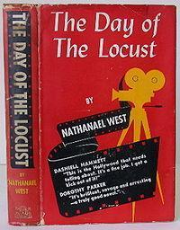

Cover of the first edition of West’s final novel, *The Day of the Locust* (1939). Taken from

<http://www.nathanaelwest.com/west/?page_id=41>

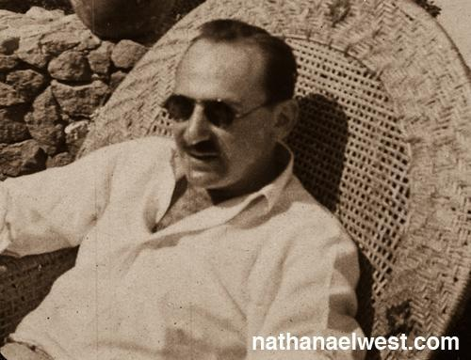

Nathanael West. Taken from: <http://www.nathanaelwest.com/west/?page_id=41&nggpage=2>

It may be easier to trace the copyright of this photo than others, though there may be slightly better pictures out there.

Project Gutenberg links to West’s novels:

*The Dream Life of Balso Snell* (1931): <http://gutenberg.net.au/ebooks06/0608931.txt>

*Miss Lonelyhearts* (1933): <http://gutenberg.net.au/ebooks06/0608851h.html>

*A Cool Million* (1934): <http://gutenberg.net.au/ebooks06/0608941.txt>

*The Day of the Locust* (1939): <http://gutenberg.net.au/ebooks06/0609041.txt>